**Learning Hub**

Design Document

**Revision History**

|  |  |  |  |
| --- | --- | --- | --- |
| **Date** | **Description** | **Author** | **Comments** |
| 27/4/2023 | Version 1 | Hasnaa  Nada | Create Design document |
| 4/5/2023 | Version 2 | Hasnaa | Update generic and model based section |
| 7/5 | Version 3 | Hasnaa | 1:Update Login and Register Design  2:add sequence diagram for each function |

# **1. Introduction**

Learning Hub Web Application is a e-Learning project aims to create an engaging and informative online articles, videos, and records. that helps learners achieve the desired learning outcomes, but this is from the macro perspective. This release will have limited features. Over a period of time, new and new functionalities will be added to the site.

Learning hub is a web platform that will act as an online free encyclopedia hosting tons of information so the users can explore and receive knowledge in different life domain and to be part of the community to contribute and share their knowledge.

1. Generic Diagrams

ERD_001

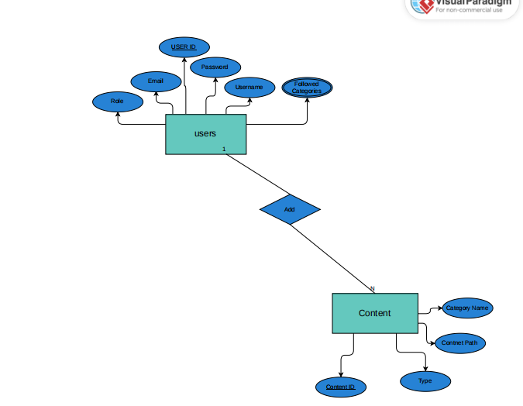

2.2 Use Case

UseCase_001

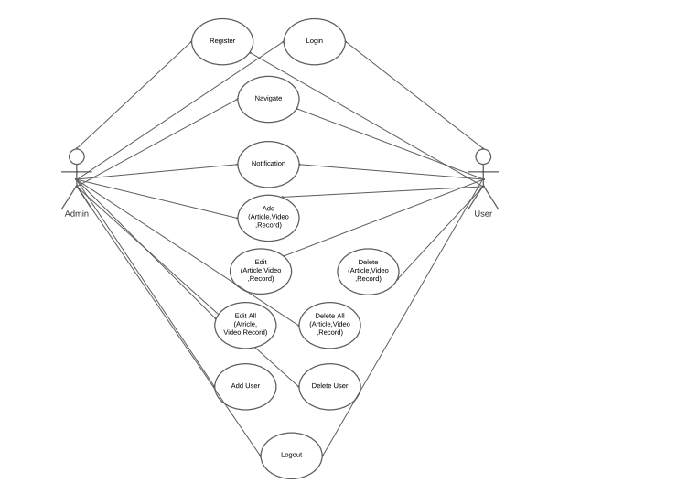

2.3 Admin sequence diagram

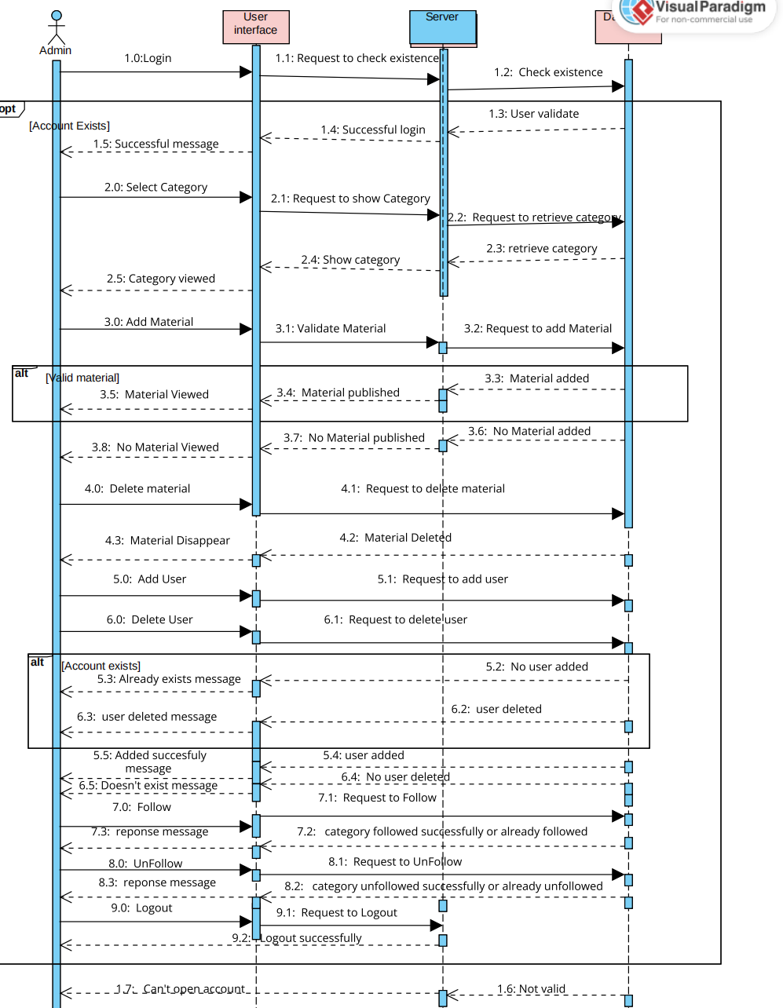

2.4 User sequence diagram

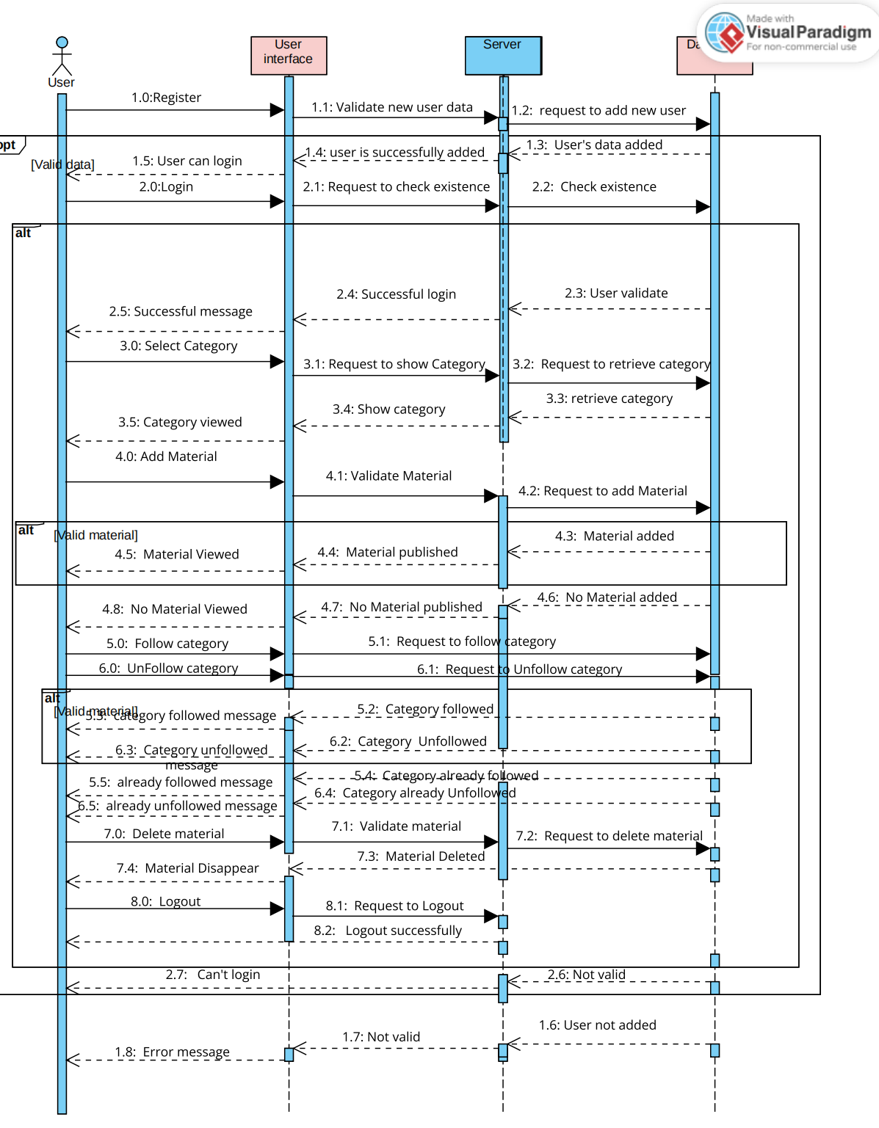

2.6 Class Diagram

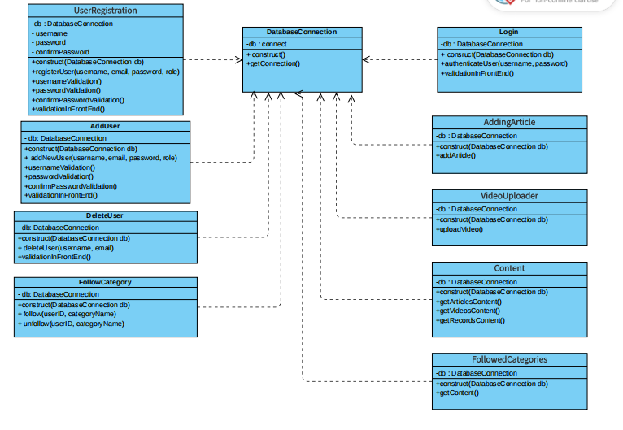

3.Model Based Diagram

**3.1 Register**

3.1.1 classDiagram_Register

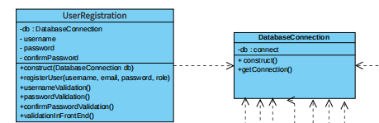

3.1.2 High Level Design

High_level_Register

3.1.2.1

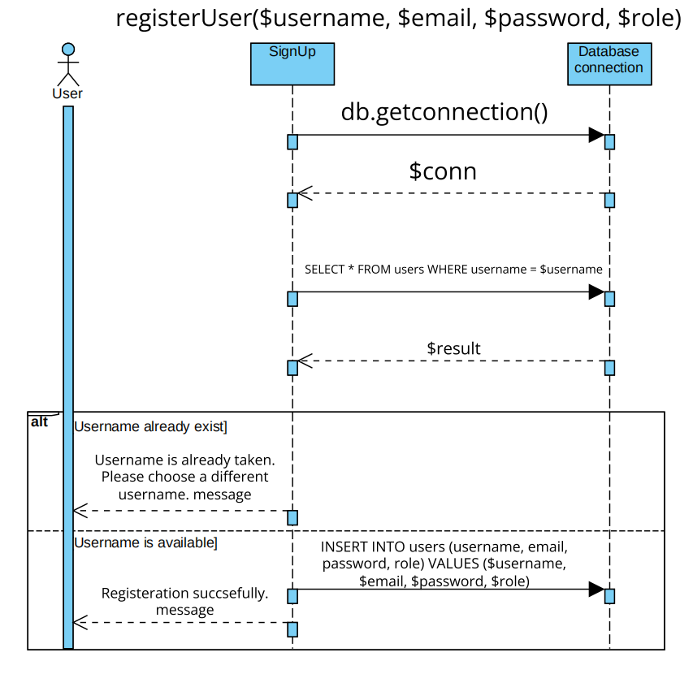

3.1.3 Low Level Design

3.1.3.1 Username Validation

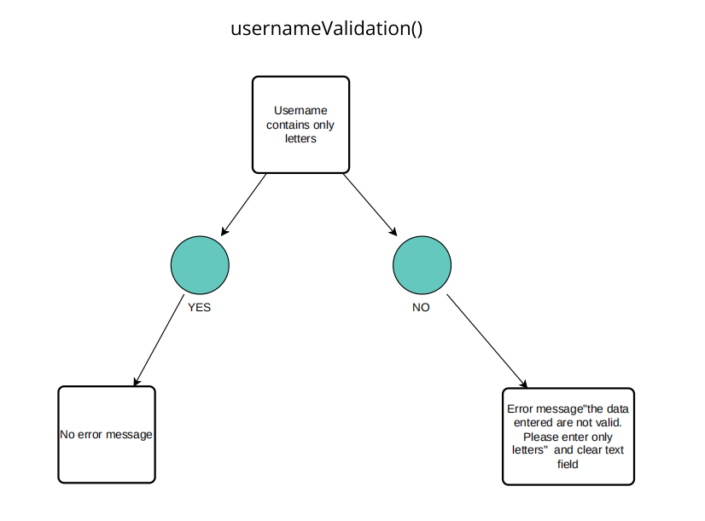

3.1.3.2 Password Validation

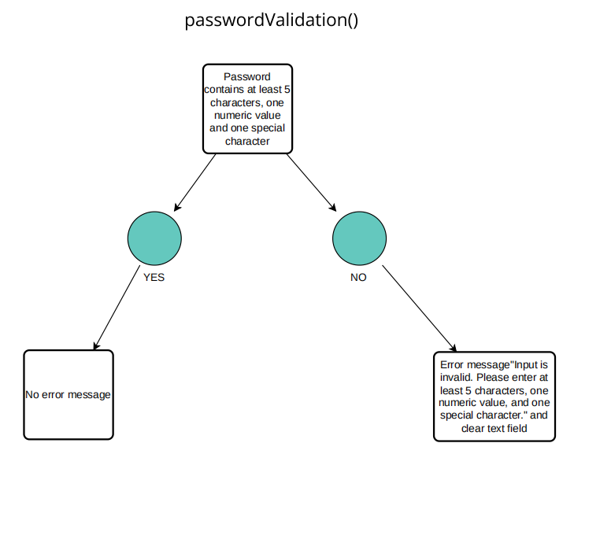

3.1.3.3 Confirm password validation

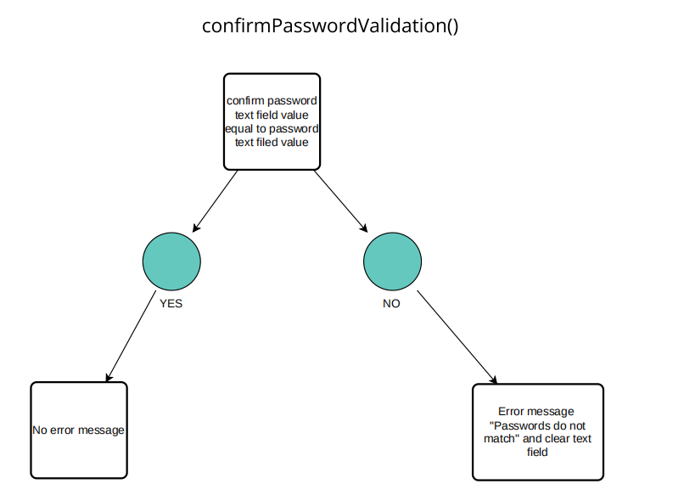

3.1.3.4 Construct(Database $db)

**3.2 Login**

3.2.1 classDiagram Login

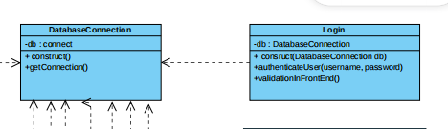

3.2.2 High Level Design

High level Login

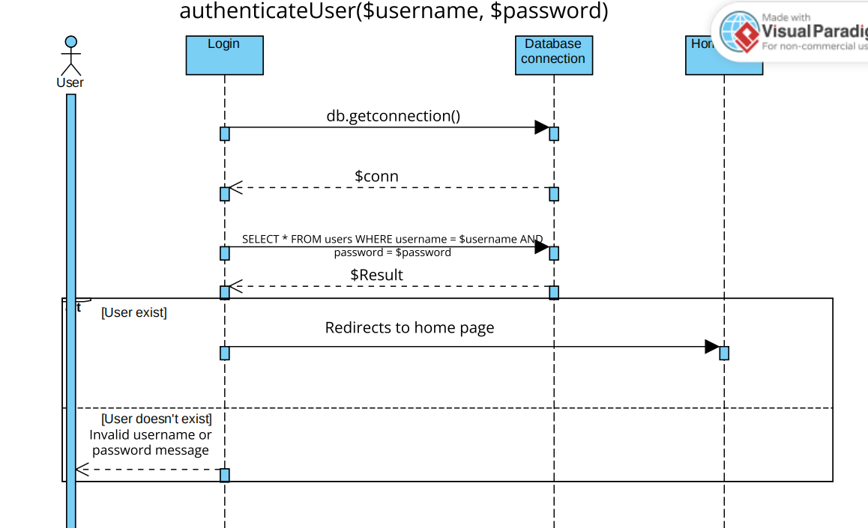

3.2.3 Low Level Design

Construct(Database $db)

Look at (3.1.3.4)

**3.3 Add content**

3.3.1 Class Diagram

classDiagram_Add content

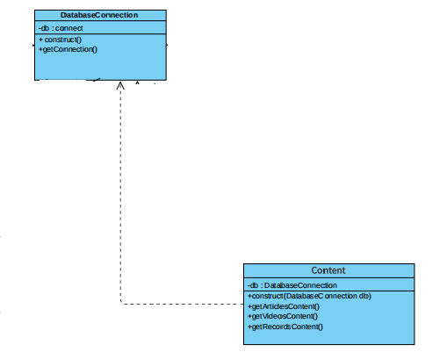

3.3.2 Low Level

Low_Design_add content

3.3.2.1

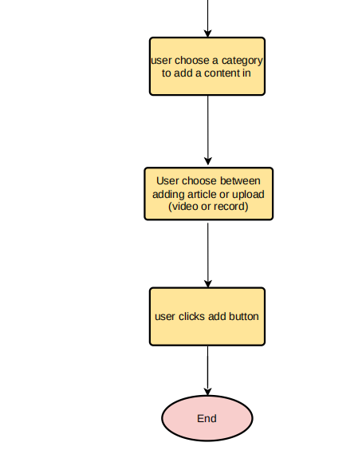

3.3.2.2

Construct(Database $db)

Look at (3.1.3.4)

3.3.3 High Level

High_Design_add content

3.3.3.1 Add Article

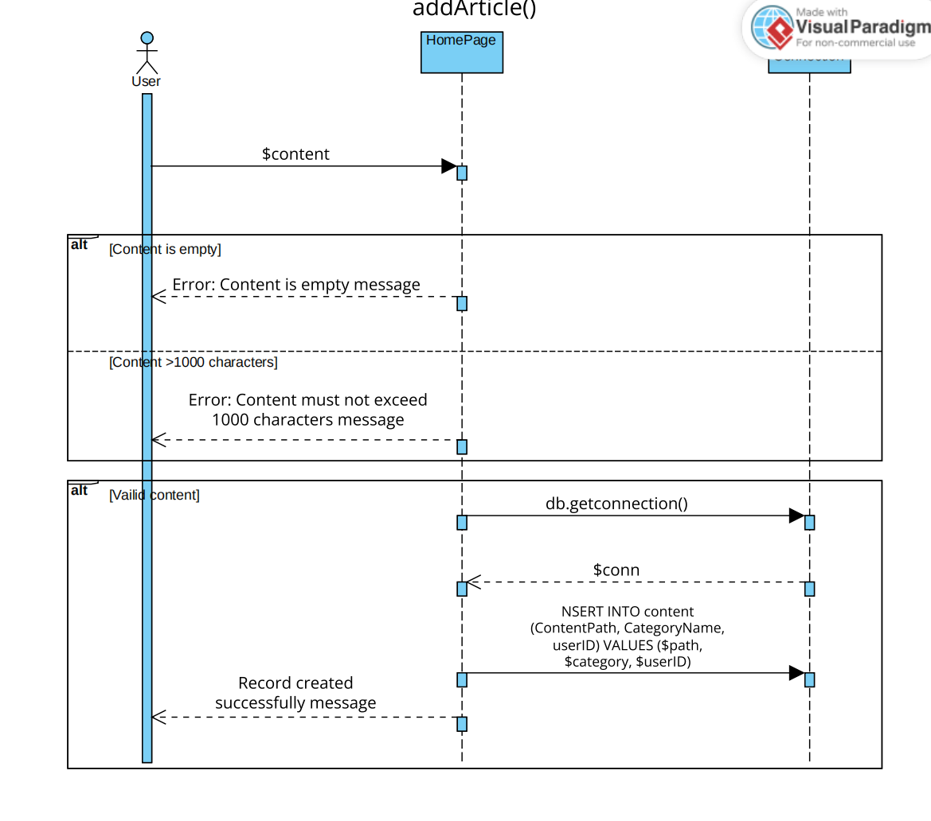

3.3.3.2 Upload Video

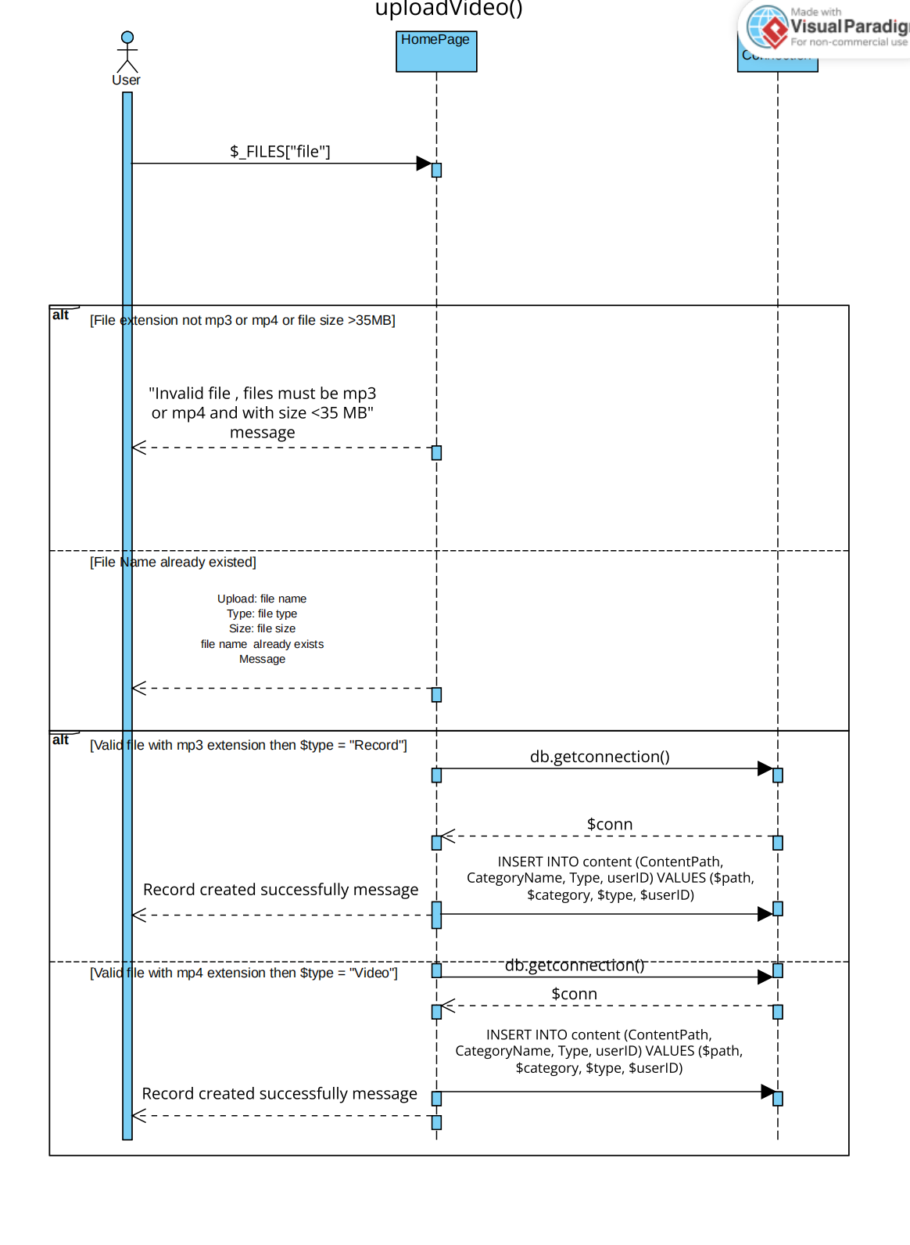

**3.4 Notification page**

3.4.1 High Level

High_Design_Notification

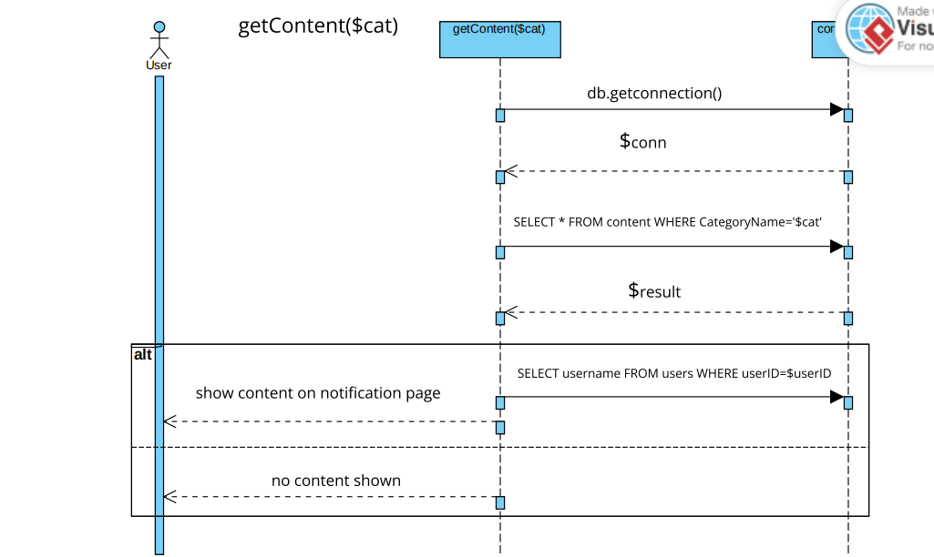

3.5 Follow Category

3.5.1 Class Diagram

classDiagram_Follow Category

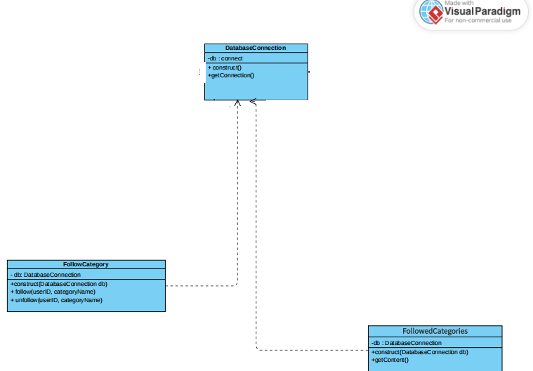

3.5.2 Low Level

3.5.2.1

Low_Design_ Follow Category

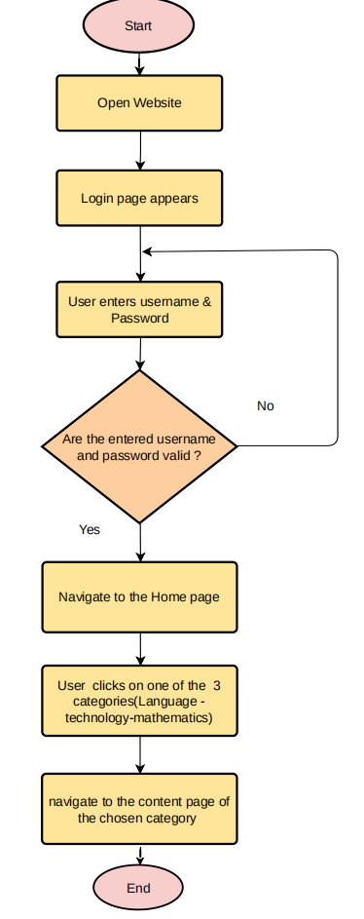

3.5.2.2

Construct(Database $db)

Look at (3.1.3.4)

3.5.3 High Level

High_Design_ Follow Category

3.5.3.1

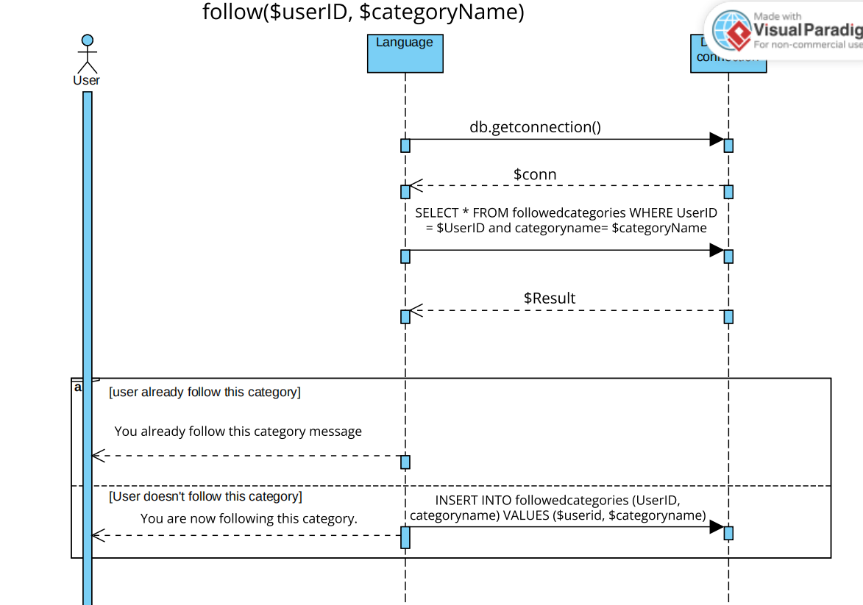

3.5.3.2

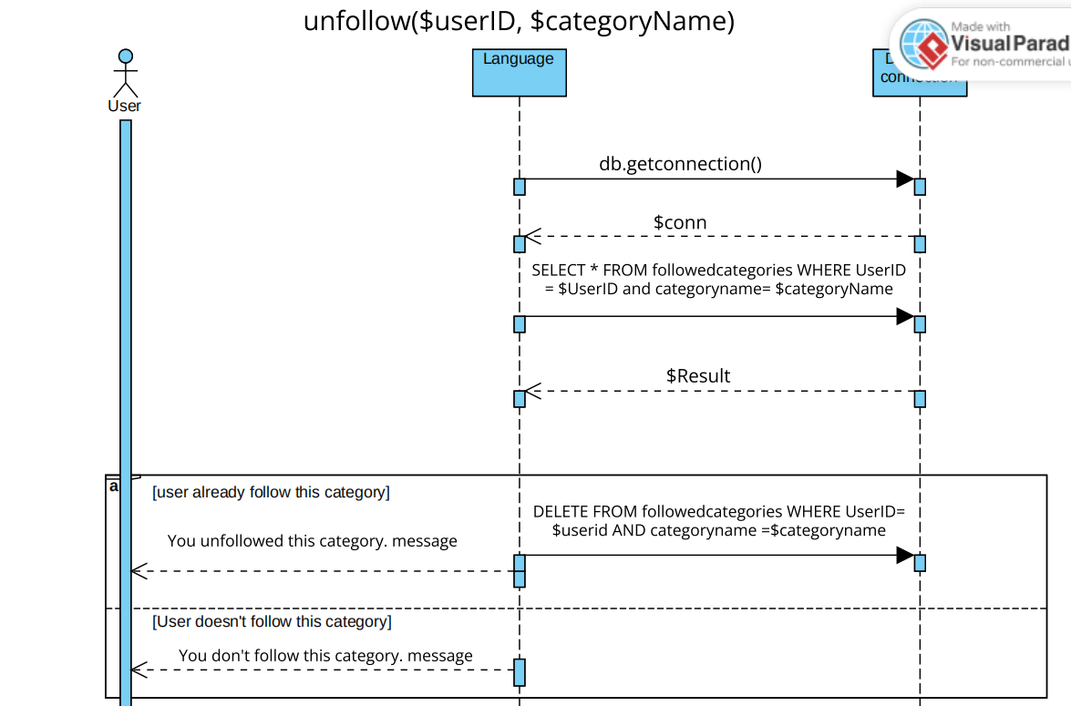

3.6 Delete Content

3.6.1 High Level Design

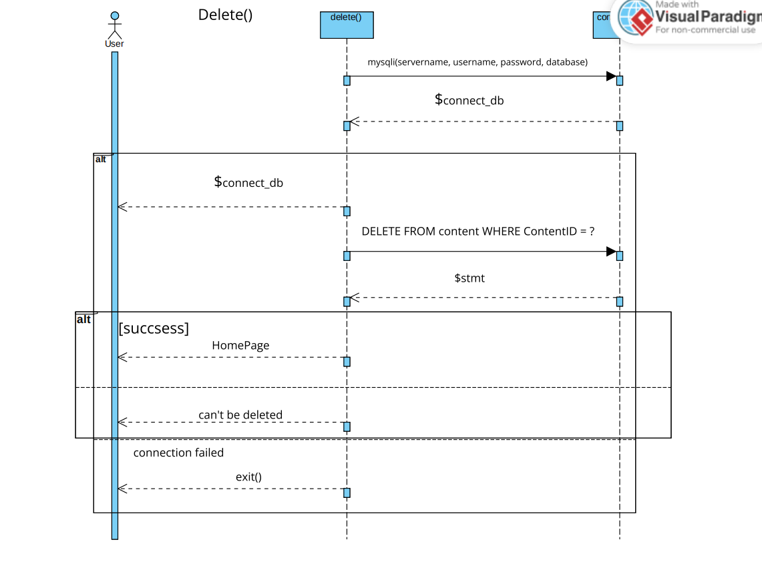

3.7 Add User

3.7.1 High Level Design

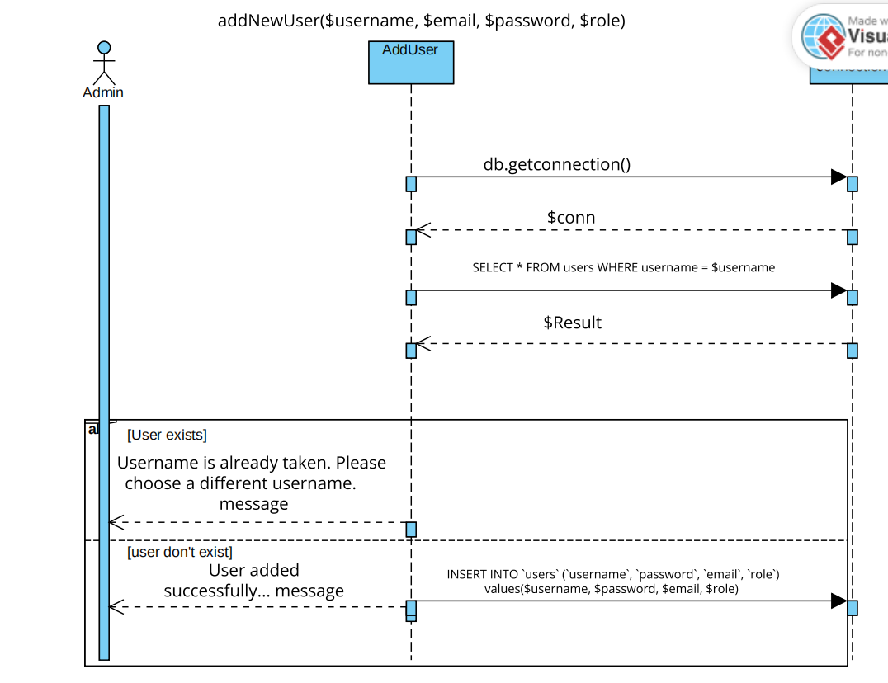

3.7.2 Class Diagram

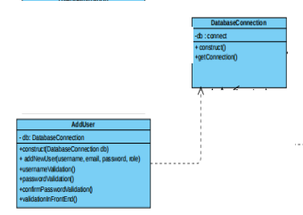

3.8 Delet User

3.8.1 High Level Design

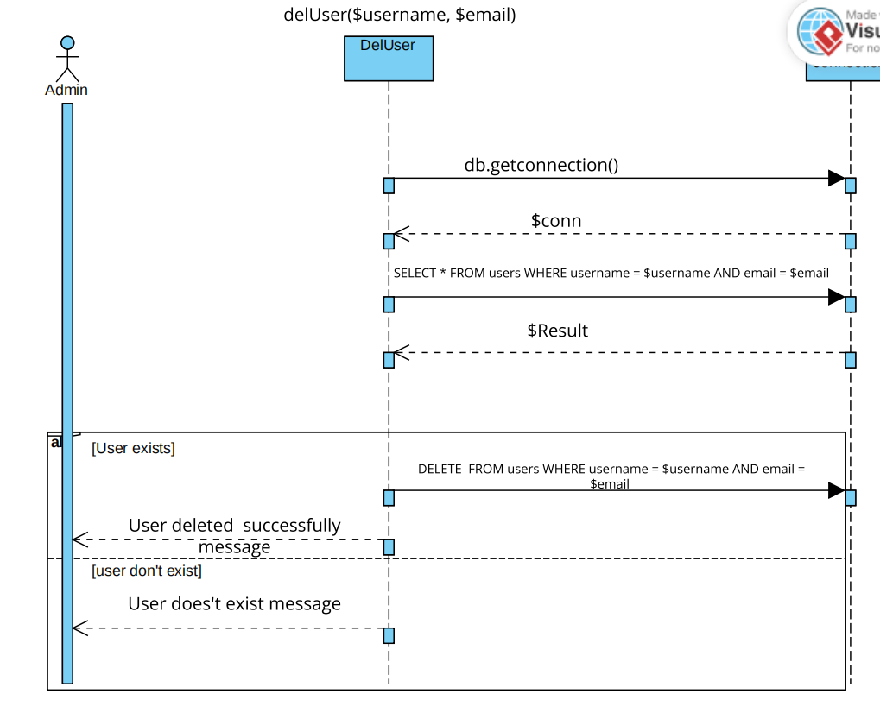



3.8.2 Class Diagram

